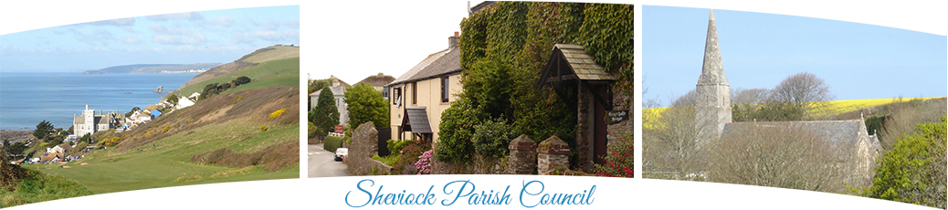
The Bill Warren Room, Sheviock Memorial Hall, Crafthole, Torpoint, Cornwall, PL11 3DG
Clerk: Mrs Nancy Gray Telephone: 01503 232996 Email: sheviockpc@btinternet.com

The Minutes of the Annual Parish Council Meeting for Sheviock Parish Council held on Monday 17th May 2021 in the Kennedy room, Sheviock Memorial Hall, Crafthole, commencing at 7.00pm
Present: Councillors: S. Medway, P. Brooks, W. Evans, L. Jenkins, I. Court and D. Lester.

In Attendance: Mrs Nancy Gray - Parish Clerk. There were no members of the public present.

Item 1. DECLARATIONS OF ACCEPTANCE OF OFFICE: Declarations of Acceptance of Office were signed by All Councillors and witnessed by the Clerk.

Item 2. ELECTION OF CHAIRMAN. Cllr Brooks nominated Cllr Medway as Chairman, seconded by Cllr Evans with all in favour. Cllr Medway accepted the position and signed a Declaration of Acceptance of Chairman’s Office, witnessed by the Clerk, and took the Chair.

Item 3. ELECTION OF VICE CHAIRMAN. Cllr Brooks nominated Cllr Evans as Vice Chair, seconded by Cllr Court, with all in favour. Cllr Evans accepted office.

Item 4. APOLOGIES. Cornwall Cllr K. Ewert sent her apologies as was attending a meeting.

Item 5. ELECTION OF THE FOLLOWING REPRESENTATIVES:
- CALC – Cllr Medway
- PLANNING – All Councillors, primarily covering their own areas within the parish.
- TREE WARDEN – Cllr Lester
- FOOTPATHS – Cllr Evans
- EMERGENCY PLAN – Cllr Court
- CAR PARK, TICKET MACHINE, SAFETY INSPECTIONS AND PUBLIC TOILETS – Cllr Medway & Cllr Evans
- OPEN SPACE/PLAY PARK INSPECTIONS – Cllr Brooks & Cllr Jenkins
- FLOWERBEDS – Cllr Evans
- TOURIST INFORMATION KIOSK -Cllr Brooks
- RAME PENINSULA PUBLIC TRANSPORT USERS GROUP -Cllr Court
- COASTAL COMMUNITY – Cllr Jenkins
- GATEWAY NETWORK – Cllr Lester
- DEFIBRILLATORS – Cllr Jenkins.
- LIBRARY LIAISON -Cllr Brooks
The chair closed the meeting at 7:08pm

Signed………………………………………………………………………… Date……………………………………………..
Chairman, Sheviock Parish Council
NB. A copy of these Minutes can be found on the Sheviock Parish Council Website: www.sheviockparish.org.uk

Please note the chairs’ annual report can be found within the minutes of the Annual Parish Meeting April 2021. On the Parish website.

