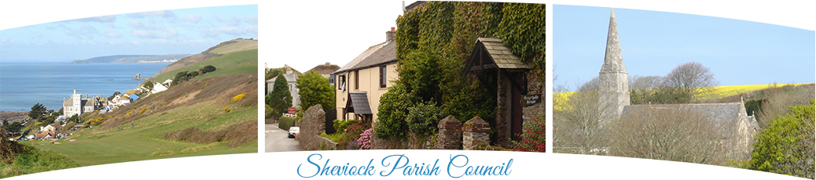

Sheviock Parish Council
Terms of Reference: Planning Committee

1. Objective

1.1 Sheviock Parish Council is an advisory body to the Planning Authority (Cornwall
Council) for all planning applications that directly relate to the parish area or
otherwise affect those living within the parish area.
1.2 The Planning Committee is constituted to consider and respond on behalf of the
Council to all applications for planning permission and planning appeals referred to
Sheviock Parish Council by the Planning Authority.

2. Membership

2.1 Membership shall consist of all members of the Full Council.
2.2 The Planning Officer will be elected at the annual meeting of Sheviock Parish Council
and will serve for a period of one year.
3 Standing Orders and Policy
3.1 The Standing Orders approved by Sheviock Parish Council for Parish Council
meetings will apply to meetings of the Planning Committee.
3.1.1 Three (3) members will constitute a quorum.
3.2 The Planning Committee and its Chairman will act in accordance with Sheviock Parish
Council’s Planning Procedure.

4 Responsibilities
4.1 All power and duties of the Council in respect of the powers conferred on it from
time to time under the Town and Country Planning Acts and the Orders and
Regulations including development control and the local planning process remain
with the Full Council of Sheviock Parish Council.
4.2 The Planning Committee at Special Planning Meetings has the delegated authority
from Sheviock Parish Council:
4.2.1 To make representations to the Local Planning Authority on applications for
planning permission which have been notified in accordance with the Local
Government Act 1972 and other relevant legislation;
4.2.2 To make representations in respect of appeals against the refusal of planning
permission;
4.2.3 To identify and make representations to the relevant authorities in respect of
enforcement action or any matters considered to be breaches of planning
regulations
4.2.4 To deal with any other planning related matter that a meeting of the full
Council considers appropriate to be referred to the Planning Committee.

5 Meetings
5.1 Meetings will be held monthly as an agenda item of the Full Parish Council with
discussion led by the Planning Officer.
5.2 Special Planning Meetings will be called in conjunction with the Chairman of the
Parish Council to consider
5.2.1 planning applications that would otherwise exceed the 21-day response time
to Cornwall Council if left to the next Parish Council meeting;
5.2.2 applications considered by the council to be contentious or of such
importance to warrant a wider debate;
5.2.3 to consider matters referred by the Full Council to the Planning Committee
for debate and recommendation.

6 Status of reports received from Special Meetings Planning Committee
6.1 Reports and minutes of Special Planning Meetings shall be received by the Parish
Council without debate

