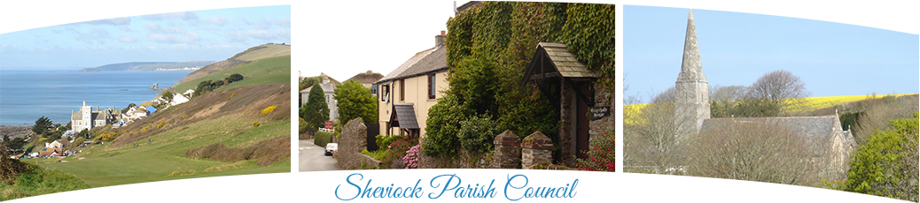
The Bill Warren Room, Sheviock Memorial Hall, Crafthole, Torpoint, Cornwall, PL11 3DG
Clerk: Mrs Nancy Gray Telephone: 01503 232996 Email: sheviockpc@btinternet.com

The Minutes of the Annual Parish Meeting held on Monday 9th of April 2018 in the Schoolroom, Crafthole Methodist Chapel, Crafthole, commencing at 6:30pm.

Present: Councillors: Chair Cllr S Medway, Vice Chair Cllr P Brooks. Cllr McGuinness. Cllr E. Ling, Cllr W. Evans, Cllr D Lester. Parish Clerk Mrs N. Gray
There were 4 members of the public present.

- The Chair Welcomed all.
- APOLOGIES. None
- MINUTES OF THE ANNUAL PARISH MEETING HELD ON APRIL 1OTH 2017. It was RESOLVED that the Chairman sign the Minutes as being a true record of that meeting. Proposed by Cllr McGuinness, seconded by Cllr Brooks, with all in favour. Clerk.
- PUBLIC PARTICIPATION: MATTERS THAT MEMBERS OF THE PUBLIC WISH TO BRING TO ATTENTION. None
- INFORMATION & PRESENTATION FROM LOCAL GROUPS.
- Sheviock Garden Club. Mrs D Medway gave a report for 2017 see appendix 1 below.
Mr Davis Dunn provided information about the following clubs:
- Short Mat Bowls meet Monday @2pm and Friday @7:30 pm in the Memorial Hall. They are in the Eastern Cornwall league, 2nd division, currently 3rd from bottom or 7th from top! It’s great fun and new members always welcome.
- Sheviock C.E Church. They are attempting to raise £250,000 via fundraising and grants to repair the spire bell tower, add an outside toilet, new kitchenette and remove some pews to increase the area inside to allow for small functions/meals.
They are organising future events to include: A champagne soiree at Antony House with a guided tour from the family, giving access to parts of the house not usually seen when visiting via the National Trust; A Parish boundary walk in September to include talks at different spots regarding focal points of interest/features. A Ticketed Barn Dance in September/October, in Sheviock Barton, with the Friday Night Boys playing.
Cllr Brooks provided information about the Crafthole Preschool:
- They have 43 children ranging from 2-4 years old and travelling from as far as St Cleer, Narkurs and Kingsand. They run term time, weekdays 09:30 -12:30 with lunch club from 12:30 -1:30pm. They run a Toddlers group on Friday (term time) from 1pm -2:30pm. Contact Paula Books 07900553116.
Mrs B. Snowling provided the information regarding the following clubs.
- Badminton, Wednesdays at the Memorial Hall. 5:30- 6:30pm children aged 7-11, 6:30 -8pm Senior school 12 to 16 year olds, adults 8pm onwards. Contact Mrs B. Snowling
- Keep fit gently Thursday 2:15 -3:15pm Contact Mrs B. Snowling
- Methodist Chapel: 10:30 Sunday service. Sunday school 9:45 -10:45. There is Coffee Morning every 4th Saturday from 10-11:30. Tuesday Club is on the first Tuesday of the month 2:30 -4pm ish, with a variety of speakers and talks each month. Bible study at Mrs Snowling’s house 3:30pm 1st and 3rd Thursdays of the month.
- Short Tennis 2:30 and Thursday at 7:30 at the Memorial Hall. Contact Mike Claughton.
The Clerk stated that she had been advised that:
- W.I. This club meets every 3rd Wednesday of the month @ 2pm in the Memorial Hall. New members always welcome. Contact Mrs Theresa Colraine or simply come along to the meeting.
- It was stated that the Village shop is always happy for new recruits to volunteer. It is social and provides a good sense of community Spirit.

There being no further business the Chair closed the meeting at 7:00pm.

Signed………………………………………………………………………… Date……………………………………………..
Chairman, Sheviock Parish Council
NB. A copy of these Minutes can be found on the Sheviock Parish Council Website: www.sheviockparish.org.uk

ANNUAL REPORT OF SHEVIOCK GARDEN CLUB 2017

2017 was an excellent year for our garden club with interesting speakers and some great outings.

Our Speakers last year included talks by Chris and Gill Kennedy (An Introduction to the Fortunate Islands and their Flora), Tricia Howard (A Year in the Garden at Hidden Valley), Nick Bacon (Growing Veg the Old Fashioned Way) and Stewart Pocock (Pococks Roses).

Trips out included Plants Galore and Saltram House, Lukesland Gardens, Harford, Lethytep, Penadlake, Lanreath (supporting Cornwall Wildlife Trust) and Saltram Illuminations.

In July we had our annual Garden Safari and Cream Tea and finally our New Year Lunch in January at The Whitsand Bay Hotel.

There were two fund raising events in July and December for the Memorial Hall and I was delighted that our Christmas stall won the prize for best display.

Our club membership is now 32 and as a result we have changed our meeting day to the 3rd Monday of the month with a new starting time of 7pm in order that we can use the main hall. Our meeting in October will, however, be on a Thursday in the bowls hall.

Dee Medway
Secretary

